LEWIS BEAR COMPANY
Student name
Course name
Nov 08, 2016
Table of content
- Executive Summary
- MARKETING PLAN
- Company Name
- Logo/ Tag Line
- Introduction
- Mission Statement/ Vision Statement
- ORGANIZATION PLAN
- Market analysis
- Target Market
- SWOT ANALYSIS
- Market segmentation
- Target market segments
- Competitive advantage
- Positioning Statement
- Marketing strategy
- Product/ service
- Pricing strategies
- Placement:
- Promotion:
- Advertising
- People
- Process
- Physical evidence
- Physical Environment
- 4 C’s that correspond with our 4
- CONTROL MEASURES
- Media plan control
- OPERATIONS PLAN
- Financial requirements
- Initial capital needed to start the business
- Salary Expenses
- Variable Costs/ Fixed Cost
- Break-even sales
- Time to Cover Initial Investment
- Growth Potentials
- Reference

Executive summary
Lewis Bear Company serves the Minneapolis metropolitan territory. Grizzly will produce new customers through a mix of systems administration and month to month open courses that present generally inaccessible fragments of the populace to Grizzly's administrations. Other than the classes growing new business, it is likewise a way that Grizzly can offer back to the community. Most of these organizations were made by business people who imagined a chance to build up another item or administration and sought after that vision looking for freedom and budgetary reward. While these visionaries began with strong thoughts to shape the establishment of their new pursuits, most don't have a large number of the abilities important to change their thoughts into reality. Furthermore, the shortage of ability in today's market makes it to a great degree troublesome for private company proprietors to draw in and hold those attitudes.

Marketing plan
Lewis Bear Company
Company Name
Lewis Bear Company is a comprehensive financial planning and estate planning consultancy. Lewis's services are comprehensive in terms of offered products (mutual funds, equities, estate planning) as well as in terms of depth of research. The up-front cost to do in-depth research into prospective investments and possible options for the client will be eclipsed by a long-term relationship that is likely to be established out of earned respect.
Logo/ Tag Line

Introduction
Lewis Bear Company serves the Minneapolis metropolitan area. Lewis will be generating new clients through a combination of networking and monthly public seminars that introduce otherwise unreachable segments of the population to Lewis's services. Besides the seminars developing new business, it is also a way that Lewis can give back to the community.
Mission Statement/ Vision Statement
Our mission is to provide comprehensive financial planning services for our customers. We exist to attract and maintain customers. When we adhere to this maxim, everything else will fall into place. Our services will exceed the expectations of our customers. Lewis Bear Company will be marketing their services to two different groups of people, those in need of investing advice, and those that are in need of estate planning help. These two groups will be targeted through networking activities and public seminars. Lewis's competitive advantage of thoroughness of services offered as well as in-depth research will turn prospective clients into long-term customers
ORGANIZATION PLAN
Market analysis
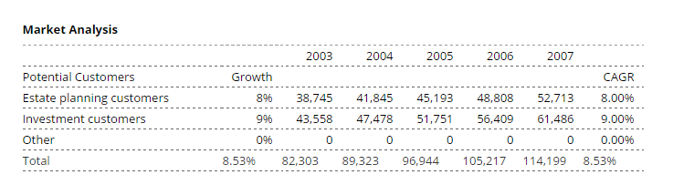
Target Market
Lewis Bear Company has picked these two gatherings since they both have cash to put and most need help with deciding how to contribute or how to structure their home. These gatherings will be focused on two strategies. The first is antiquated systems administration. Meghan made a considerable measure of contacts in her interest for her MBA. Notwithstanding organizing her contacts from school, Meghan will likewise arrange to utilize her social contacts. Meghan will likewise be focusing on gatherings through the generation of open workshops on domain arranging and contribute. These courses commonly happen in an open range, for example, a library corridor. The workshops give a fundamental level of learning. The workshop is not intended to supplant Meghan's administrations; they are intended to whet individuals' hunger for more data. The genuine explanation behind these, however, is to get a different jam of individuals intrigued by Meghan and the administration's she offers, doing new business.
SWOT ANALYSIS
Strengths
- Money related skill, both viable and instructive.
- Solid relationship-offering strategies.
- A demonstrated plan of action with a client drove core interest.
Weaknesses
- Low brand control, an element of being a new business.
- The trouble is creating brand value with a restricted promoting spending plan.
- A harsh initial six months because of the low volume of customers.
Opportunities
- Support inside a steady, developing industry.
- The genuine requirement for budgetary guides by the larger part of individuals.
- Finding the business inside a emerging metropolitan range.
Threats
- A budgetary counselor embarrassment that shakes the certainty of purchasers unreasonable in view of the wrongdoings of a firm or a little number of firms.
- The multiplication of money related counselor chains, the likeness H and R Block in the expense world.
Market segmentation
Two types of essential research will be utilized for advertising exercises. The primary sort was a concentration gathering that was held a while before the written work of the advertising arrangement. The concentration gathering was a little gathering of individuals united with a facilitator driving the discourse. The initial segment of the concentration gathering was organized, with effectively settled inquiries. The second part of the concentration gathering was a free stream talk that permitted members to examine things that were at the forefront of their thoughts (Louis E. Boone, 2014).
The second type of essential research was a client study. The review was given to potential clients and asked into their inclinations and requirements. Both types of essential statistical surveying were extremely smart and furnished this advertising arrangement with a lot of data that would have been generally hard to gather. In the year 2000, the money related consultant showcase created $9 billion in income. Money related arranging is a calling that requires loads of data and time to make progress. The vast majority don't have room schedule-wise to make an appropriate showing with regards to so they swing to experts. Since budgetary making arrangements for the retirement years is particularly imperative, the requirement for money related administrations won't likely be fundamentally reduced at any point in the near future.
Target market segments
In the year 2000, the money related consultant showcase created $9 billion in income. Money related arranging is a calling that requires loads of data and time to make progress. The vast majority don't have room schedule-wise to make an appropriate showing with regards to so they swing to experts. Since budgetary making arrangements for the retirement years is particularly imperative, the requirement for money related administrations won't likely be fundamentally reduced at any point in the near future.
Competitive advantage
Lewis is entering its first year of operations. Lewis offers money related arranging, contributing administrations and domain arranging and has recognized two market portions that it will serve. Lewis has assembled a considerable measure of data about its objective clients and will influence this data to address the issues of the focused on clients. The fundamental market need is an extensive budgetary arranging and home arranging consultancy.
Positioning Statement
Lewis Bear organization will position itself as a thorough money related consultancy for monetary and bequest arranging in the Minneapolis metropolitan range. The accompanying aggressive edge will be utilized to accomplish the wanted situating. Lewis Bear organization' upper hand is its far-reaching way to deal with research and administrations gave. It is Meghan's logic that she can grow more esteem for her clients by contributing time in advance while looking into changed alternatives. Most arranging firms will do satisfactory research as far as investigating diverse alternatives. Absolutely enough to meet due ingenuity necessities. While this is adequate for a few, Meghan sticks to the rationality that it is ideal to put the time forthright in support of the clients. This will then result later on by growing enduring connections. This tender loving care and painstaking quality will absolutely be valued by customers who fundamentally are believing their monetary future to Meghan.
Marketing strategy
The marketing strategy will comprise of a few exercises used to build deceivability for the association and spread data about Lewis.
The proprietor, Meghan, will offer open courses on request arranging and monetary arranging in Minneapolis here and there a month. These workshops will have sponsored rates and urge individuals to go to and learn however much as could be expected. These classes will regularly happen in an open building and offer a general discourse on the subject (Robert N. Lussier, 2014).
Meghan will alert individuals against exclusively utilizing this data to decide. Rather they will be urged to see an expert exclusively so they can better evaluate the client's needs. The workshops will endeavor to get these individuals to begin contemplating their monetary future. These workshops are a decent and proficient method for acquainting Meghan with customers who might some way or another not in any manner be acquainted with her.
Meghan will likewise be doing a lot of systems administration to rustle up business. One exceptional wellspring of systems administration is with her companions from her MBA program. While everybody that experienced the MBA program has a decent instructive establishment for monetary administration, the vast majority don't do their own particular arranging yet are helped by an authority.
Meghan will get in touch with her associates through social events, staying in contact with them, and offering her administrations in the event that they are in need. These two techniques will precisely focus on the divided populaces and permit Meghan to assemble her customer list. Ultimately, Lewis Bear will utilize ads to impart its message.
Product/ service
The single goal is to position Lewis Bear Company as an all-around regarded budgetary and bequest arranging consultancy serving two particular market fragments. The advertising technique will try first to make client mindfulness with respect to the administrations offered, build up the client base, and work toward building client faithfulness and referrals. The message that Lewis tries to impart is that it offers a thorough monetary and bequest arranging administration. This message will be conveyed through a few unique techniques. The principal technique is through open workshops used to acquaint planned clients with Lewis and its abnormal state of mastery. Another technique for correspondence will be vital systems administration. The systems administration will be a purposeful, relentless push to influence the individual and expert connections that Meghan has created throughout the years. The last technique will be with the utilization of promotions.
Pricing strategies
In time, LEWIS BEAR COMPANY may consider a money and value course of action, or possibly all value for particular ventures. Before we can start with this phase of evaluating, we will require more experienced fund and bookkeeping aptitudes to decide appropriate value stakes that ought to be asked for, and so forth. Moreover, LEWIS BEAR COMPANY will offer financially savvy Web-facilitating administrations that will give progressing income streams. It is foreseen that most customers will agree to our one-year contracts requiring negligible bookkeeping.
Placement: The estimating plan will be at a widely appealing value point.
Promotion: The offered administrations will be circulated from Lewis's office space.
Advertising: Public classes, focused on systems administration, and publicizing will be the techniques utilized.
People
We put our best individuals on private venture clients. Our central goal is to help independent companies of today turned into the main organizations of tomorrow. Cambridge Strategy Group will endeavor to possess the words "independent venture" in the psyches of our potential customers.
Process
Financially savvy individual connection with neighborhood expert nearness. Individual collaboration gives independent ventures a level of solace not accessible to remote specialists. There might be numerous events where the private company authors may ask the specialist to just "make a trip," to respond to another advancement or to answer a question. While this nearby nearness and individual cooperation are very esteemed, entrepreneurs are regularly not able to bear the cost of the cost connected with conveying specialists to them from different ranges (Dyro, 2004).
Physical evidence
A various system of specialists and organization together accomplices. Tackling the one of a kind issues that face independent ventures today requests an extensive variety of aptitudes and encounters. By depending on a broadly disseminated ability base facilitated to cooperate remotely, Cambridge Strategy Group will have the capacity to unite the aptitudes required by a specific customer without acquiring the cost of physically bringing the majority of the people together. With 898,000 private companies beginning every year, there is a noteworthy open door for a counseling firm, for example, Cambridge Strategy Group to wind up the "principal" counseling firm committed only to independent companies in the brains of some of these potential customers.
Physical Environment
The firm has small capital requirements. Any capital that the firm gets will be utilized to advance the "private company center" of the firm and take care of fundamental operational expenses. For the firm to understand its maximum capacity, the originators would require remuneration comparable to all day business while seeking after introductory customers and making a build-up of work solicitations. This would in all likelihood need to cover no less than one year's pay for each of the three directors. Furthermore, subsidizing for introductory showcasing activities would guarantee that the firm could build up a claim to the "independent company counseling" idea in the objective market. In return for the subsidizing, CSG would give a value stake to the financing organization. In a perfect world, we might want to work with the financing organization to help its different customers succeed.
4 C’s that correspond with our 4
CONTROL MEASURES
The motivation behind Lewis's showcasing arrangement is to serve as a guide for the association. The accompanying regions will be observed:
Income: month to month and yearly.
Return on investment (ROI): singular customers and gathering reserves.
Consumer loyalty. (Stasch, 2010)
Media plan control
Choosing how to introduce an imaginative thought to the market is basic. We have mastery in transforming that thought into an effective business wander. Our market arranging administration's help independent venture originators decide the best informing for their organizations through the market and aggressive investigation.
OPERATIONS PLAN
We then take the data picked up in our examinations and make a successful showcasing blend including the majority of the components of item or administration definition. At long last, we can help our customers build up a dispatch plan to give their item or administration a decent possibility at the achievement. Whenever fundamental, we will create advertising or business improvement organizations.
Financial requirements
The organization is sorted out as a supervisor oversaw Limited Liability Company. At first, we will have three individuals with equivalent value stakes in the organization settling on all voting choices. An official executive who is one of the administrators will be distinguished to run gatherings and give some type of request to continuous dialogs. Furthermore, we will enlist experts as expected to help our customers. Advisors will be paid on a for each deliverable premise.
Initial capital needed to start the business
Salary Expenses

Variable Costs/ Fixed Cost
To improve charging to customers, the Cambridge Strategy Group will deal with a settled evaluating structure. LEWIS BEAR COMPANY will decide the standard valuing structure for every deliverable in light of hourly gauges and charges. This will be communicated to the customer as a for every altered deliverable cost in a quote. Customers can figure out which deliverables they might want to buy. LEWIS BEAR COMPANY will charge the cited cost regardless of the possibility that we have thought little of hours, to keep up believability with spending plan cognizant independent companies. The evaluating structure will be founded on $90/hour duplicated by the quantity of hours that it would take our most experienced advisor to complete the venture. On the off chance that less experienced advisors take an interest in the venture, it will probably take additional time; in any case, the cost of the deliverable to the customer won't change (Mosho, 2009).
Break-even sales
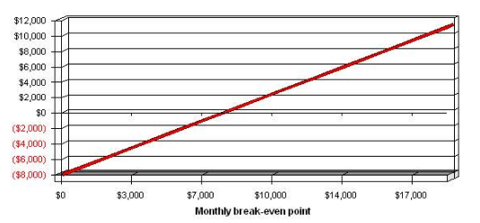
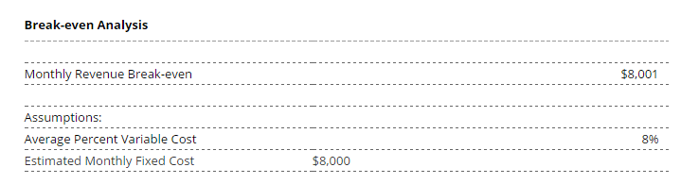
Time to Cover Initial Investment
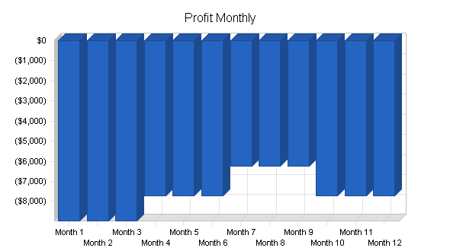
Growth Potentials:
As indicated by late research from the U.S. Independent company Administration office, a record number of new private companies opened their entryways in 1998. This record was softened again up 1999 as the general private venture advertise grew 1.5%. The development of the market is not about as essential to the Cambridge Strategy Group as its size. LEWIS BEAR COMPANY should concentrate on the best way to catch the most out of the current market, regardless of the possibility that it decreases in size, before pondering extending. Possibly, the low development may discourage a few contenders from entering the market, giving the Cambridge Strategy Group with a chance to catch market and mind-share before more contenders enter (McCrary, 2002).

References
Dyro, J. F. (2004). Clinical Engineering Handbook - Page 650.
Louis E. Boone, ‎. L. (2014). Contemporary Marketing, Update 2015 - Page 672.
McCrary, S. A. (2002). How to Create and Manage a Hedge Fund: A Professional's Guide.
Mosho, M. M. (2009). Jump Start Your Business: Everything You Need to Know to Succeed.
Robert N. Lussier, ‎. C. (2014). Entrepreneurial New Venture Skills - Page 188.
Stasch, S. F. (2010). Creating a Successful Marketing Strategy for Your Small New Business.

